Adult Learning 19+
Booking Essential
**FREE tuition for people on most means tested benefits (proof required at first session)

Creative Writing: Short Stories for Beginners
Eastwood Library
Do you want to write short stories but don’t know where to start? Or have you been writing short stories for a while yet would appreciate a helping hand?

The course includes finding story ideas and creating characters as well as how to structure and develop your short stories. We will also examine techniques used in published texts and use this to inspire new writing.
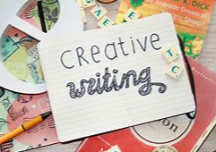

Eastwood Library
Nottingham Road
Eastwood
Nottinghamshire
NG16 3GB
Starts: Sat 25th Feb 2023
Time: 10:00 – 12:00
For: 6 Weeks
COST: £36.00

